SUPERIOR GEARBOX COMPANY
PO Box 645, Stockton, Missouri, 65785 1-800-346-5745
417-276-5191 FAX 417-276-3492 superiorgearbox.com

I210/I260/I280 WORM GEAR DRIVES

SERVICE MANUAL

SAFETY PRECAUTIONS

CAUTION

Please read this entire document prior to operating the gear drive. Gear drive failure and / or injury to operators may be caused by improper installation, operation or maintenance.
The buyer shall be responsible to:
- Determine if the gear drive selected is mechanically adequate for the chosen application and to verify that published catalog capacities are not exceeded.
- Ensure that all connected rotating parts in the system are free from critical torsional or any other type vibration.
- Eliminate any obstruction to cooling airflow when mounting the gear drive. Also consider any accumulation of external debris which could reduce cooling airflow over the unit during operation.

INSTALLATION

Gear drives must be mounted on a rigid, structurally sound baseplate. Flatness within 0.010 in. is recommended. Ensure that gear drive mounting pads rest evenly on the baseplate. The use of shims may be required to avoid housing distortion which could alter the gear mesh or cause premature bearing failure.

The gear drive may be driven by direct coupling, flexible coupling, or V-belt drive. Couplers should require only a light force to install. The driveline must be accurately aligned within the equipment manufacturer’s requirements to limit operating loads and minimize thrust loads on the gear drive shaft. V-belt drives must be mounted close to the housing to minimize excessive overhung loading which could result in early bearing or shaft failures. Sheaves must fit correctly. At installation, a tight forced fit could move the shaft from its normal position and cause internal damage. A loose fit could induce excessive vibration during operation and cause shaft damage or breakage.
!
WARNING
When mounting the gear drive, the buyer is responsible to properly determine the quality or grade of fastener, thread engagement, load carrying capacity and torque requirements.
!

WARNING
The buyer is responsible to provide protective shields over all external rotating parts, couplers, or shaft extensions mounted on or with the gear drive. Eye shields and protective clothing must be worn when installing or maintaining the gear drive and operating system.

SUPERIOR GEARBOX COMPANY
PO Box 645, Stockton, Missouri, 65785 1-800-346-5745
417-276-5191 FAX 417-276-3492 superiorgearbox.com

I210/I260/I280 WORM GEAR DRIVES

SERVICE MANUAL

Initial operation should be carried out under no-load conditions. Before applying power
to the gear drive installation, review the following:
- Check tightness of mounting bolts.
- Check for proper oil level in gear drive.
- Be certain that tools, debris, etc., are clear from rotating parts.
- Rotate the input shaft by hand. If it does not rotate freely, check for uneven mounting, coupling misalignment, or excessive belt tension.
If all tests are satisfactory, make connections to shaft(s), ensure that all safety devices are in place, and begin operation.

LUBRICATION

All gear drives are factory tested prior to shipment. They include the correct amount of oil unless specified by the customer to be shipped dry. The amount of oil in gear drives varies depending on mounting position. In general, the oil level should, as a minimum, partially cover all bearings when the unit is not running. To determine specific oil quantity and type for each model gear drive, contact Technical Support or refer to the associated Superior Gearbox drawing.

CAUTION

Prior to operation, make sure the gear drive contains the correct amount of oil. If under-filled or over-filled, damage to the gear drive or injury to personnel may result.

Approved Lubricants:
- For gear drives operating in an ambient temp of 15° to 125° F, and oil temperatures to 200° F, Mobilube EP 85W140 (or equivalent) is recommended.
- For gear drives requiring start-up in an ambient temp below 15° F or operating continuously above 200° F, Mobilube synthetic SHC 80W140 (or equivalent) is recommended.
- For low RPM applications, Mobilux EP 0 grease (or equivalent) may be used.

CAUTION

Do not combine synthetic with non-synthetic oils in the gear drive.

SUPERIOR GEARBOX COMPANY
PO Box 645, Stockton, Missouri, 65785 1-800-346-5745
417-276-5191 FAX 417-276-3492 superiorgearbox.com

I210/I260/I280 WORM GEAR DRIVES

SERVICE MANUAL

MAINTENANCE
!
WARNING
Disconnect power prior to any maintenance and do not bypass or inactivate any safety or protective device. Lock out and tag the power supply to prevent unexpected application of power.

Routinely inspect mounting bolts, couplers, or other power transmitting devices to ensure all parts are firmly anchored. Keep shafts and vent plugs (when included) clean to prevent foreign particles from entering seals or housing. Inspect daily for any oil leaks and any unusual noises. Inspect weekly for end play in shafts. Inspect belt drive tension after the first ten hours of operation and periodically thereafter.

Check the oil level every 24 hours of operation. Change the oil when the gear drive has been in service for 50 hours. Routine oil change intervals will vary for each particular installation depending on the severity of the environment. Normal changes should occur between 250 and 1000 hours of operation. The longest life at continuous service will be realized when the oil temperature does not exceed 200° F. For oil substitutions, or for high input speeds, contact Superior Gearbox.
!
WARNING
Do not change or add oil while the gear drive is running. Damage to the gear drive or injury to personnel may result. The gear drive housing, oil, plugs, and associated components may reach high temperatures and cause severe burns. Use extreme care when servicing the gear drive.

LONG TERM STORAGE or INACTIVITY

When a gear drive is stored, prior to initial installation, or following removal from service, the following steps are recommended:
- Fill completely with oil. Attach a prominent notice that the gear drive must be drained and refilled to the proper level prior to start-up.
- Apply a rust preventive to the externally exposed shafts.
- Store the gear drive in a temperature and humidity controlled area.
- Periodically, rotate the input shaft by hand.
If the gear drive is in service but inactive for 60 days or more, periodically rotate the input shaft by hand and check the oil level prior to start-up.

SUPERIOR GEARBOX COMPANY
PO Box 645, Stockton, Missouri, 65785 1-800-346-5745
417-276-5191 FAX 417-276-3492 superiorgearbox.com

I210/I260/I280 WORM GEAR DRIVES

SERVICE MANUAL

GEAR DRIVE DISASSEMBLY

Gear drive disassembly should be accomplished in a clean, dry, and well lighted area. For a general representation of gear drive parts, see the generic gear drive illustrations on pages 7 and 8. For specific model or assembly information, contact Superior Gearbox.
!
WARNING
During operation, the gear drive housing, plugs, and oil may reach high temperatures. To avoid severe burns after removing from operation, allow sufficient time for the gear drive to cool to ambient prior to disassembly.

- Drain oil by removing a bottom drain plug (refer to the assembly drawing). If the unit is filled with grease, proceed to step 2.
- Remove all hex bolts from the housing cover and from the two input caps or from one input cap and a hydraulic adapter.
- Remove the housing cover carefully to prevent damage to the cover gasket.
- Remove the worm wheel, bearings, and output shaft (if solid shaft unit) as an assembly. If the bearings will be replaced, note the location and number of any shims used. These should be reinstalled in the same sequence when the unit is reassembled. Press out the oil seals in both the housing and cover and discard.
- Remove the two input caps or input cap and hydraulic adapter. Note the location and number of any shims used. These should be installed in the same sequence when the unit is reassembled.
- Using a small arbor press or a rubber mallet, drive out the input shaft / worm gear and bearings. Press out any oil seals remaining in the housing and discard.
- If the bearings must be replaced, use extreme care to prevent any damage to the seal areas when using press equipment during removal and re-installation. The seal surface finish must be 8 to 25 micro-inch. Both the bearing and seal areas should be polished after bearing removal, however, do not reduce their diameters by excessive polishing or burnishing.
- If gear replacement is required, use extreme care during removal and replacement of any keys to prevent damage to the shaft seal area. (Note: Only the I210 series uses a keyed input worm gear).

SUPERIOR GEARBOX COMPANY
PO Box 645, Stockton, Missouri, 65785 1-800-346-5745
417-276-5191 FAX 417-276-3492 superiorgearbox.com

I210/I260/I280 WORM GEAR DRIVES

SERVICE MANUAL

GEAR DRIVE REASSEMBLY

CAUTION

The reassembly area should be clean, dry, well lighted and free from oil, grease, or any debris which could contaminate the gear drive oil, bearings or seals.

- Prior to assembly, all mating surfaces of the unit must be clean and free from oil or debris.
- SOLID SHAFT UNIT (See page 7): Install key and retaining ring onto output shaft. Insert shaft into gear wheel from rear (wheel cover) side until retaining ring seats into hub recess. Re-install the same number, and in the same sequence, any shims removed during the disassembly process. Press the inner bearing cones onto both sides of shaft until seated onto gear wheel or shims. HOLLOW BORE UNIT (See page 8): Re-install onto the worm wheel the same number, and in the same sequence, any shims removed during the disassembly process. Press the inner bearing cones onto both sides of the worm wheel until seated onto hub or shims.
- Press the outer bearing cups into the housing and wheel cover.
- Install the gear wheel into the housing and bolt on cover (use only 4 alternating bolts).
- CHECK OUTPUT ROLLING TORQUE
- Rolling torque shall fall within 5 to 25 in-lbs. If not within limits, contact Technical Support at Superior Gearbox.
- Remove cover and worm wheel from housing.
- Install keyed worm gear onto input shaft (I210 series only). Press inner bearing cones onto shaft. Insert shaft / gear assembly into housing.
- Install outer bearing cups into both ends of housing. Re-install the same number, and in the same sequence, any shims removed during the disassembly process. Install seals into end caps. Install end caps (with gaskets) onto housing. Note that shims are positioned between bearing cup and nose of end cap. Ensure that seals are not damaged by shaft during installation. Tighten end cap bolts alternately, such that the outer bearing cups are moved into proper position in housing.
- Re-install worm wheel, meshing gear teeth with worm. Bolt on cover (4 alternating bolts).
- CHECK INPUT ROLLING TORQUE
- Check rolling torque thru the input, which shall fall within 5 to 15 in-lbs. If not within limits, contact Technical Support at Superior Gearbox.
11. SET GEAR MESH
- Remove wheel cover and gear wheel. Coat gear wheel teeth with lithium base grease (white or yellow). Re-install into housing with cover. Rotate input shaft to complete one revolution of gear wheel. Remove wheel cover and gear wheel. Check mesh pattern on wheel teeth. Gear teeth should mesh on the centerline of gear wheel within ± .03. If not on centerline, contact Technical Support at Superior Gearbox.
12. Reassemble. Torque 5/16-18 screws to 17-21 ft-lbs. Fill with the proper amount of oil through the oil fill hole. Replace the fill plug. This completes the reassembly.
SUPERIOR GEARBOX COMPANY
PO Box 645, Stockton, Missouri, 65785 1-800-346-5745
417-276-5191 FAX 417-276-3492 superiorgearbox.com

I210/I260/I280 WORM GEAR DRIVES

SERVICE MANUAL

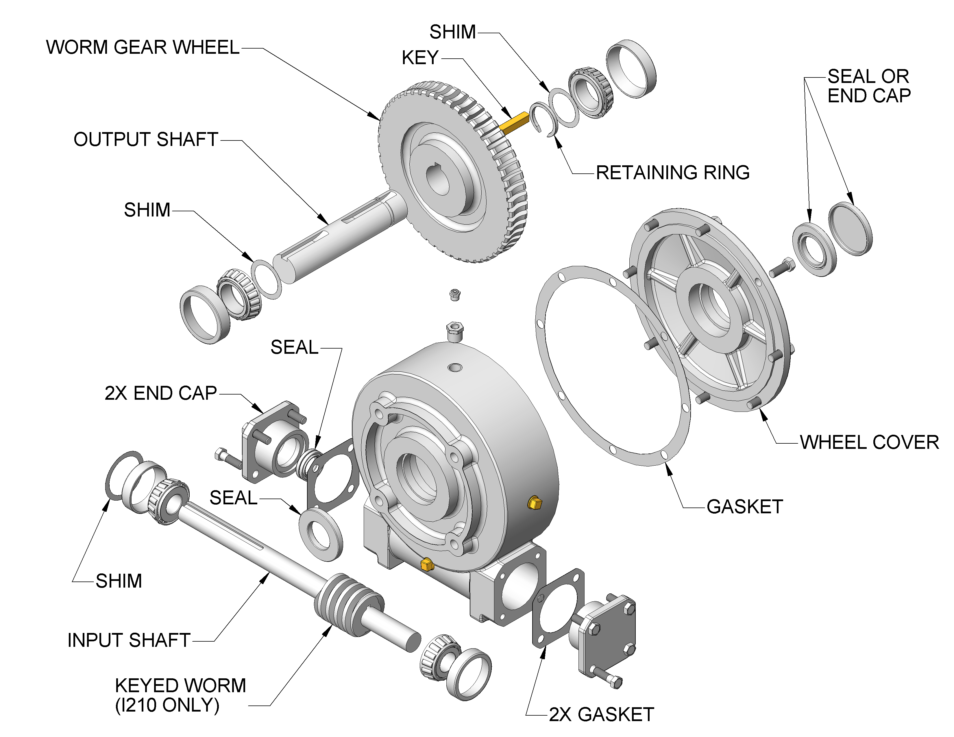

GENERIC WORM GEAR DRIVE ILLUSTRATION

SOLID SHAFT UNIT

SUPERIOR GEARBOX COMPANY
PO Box 645, Stockton, Missouri, 65785 1-800-346-5745
417-276-5191 FAX 417-276-3492 superiorgearbox.com

I210/I260/I280 WORM GEAR DRIVES

SERVICE MANUAL
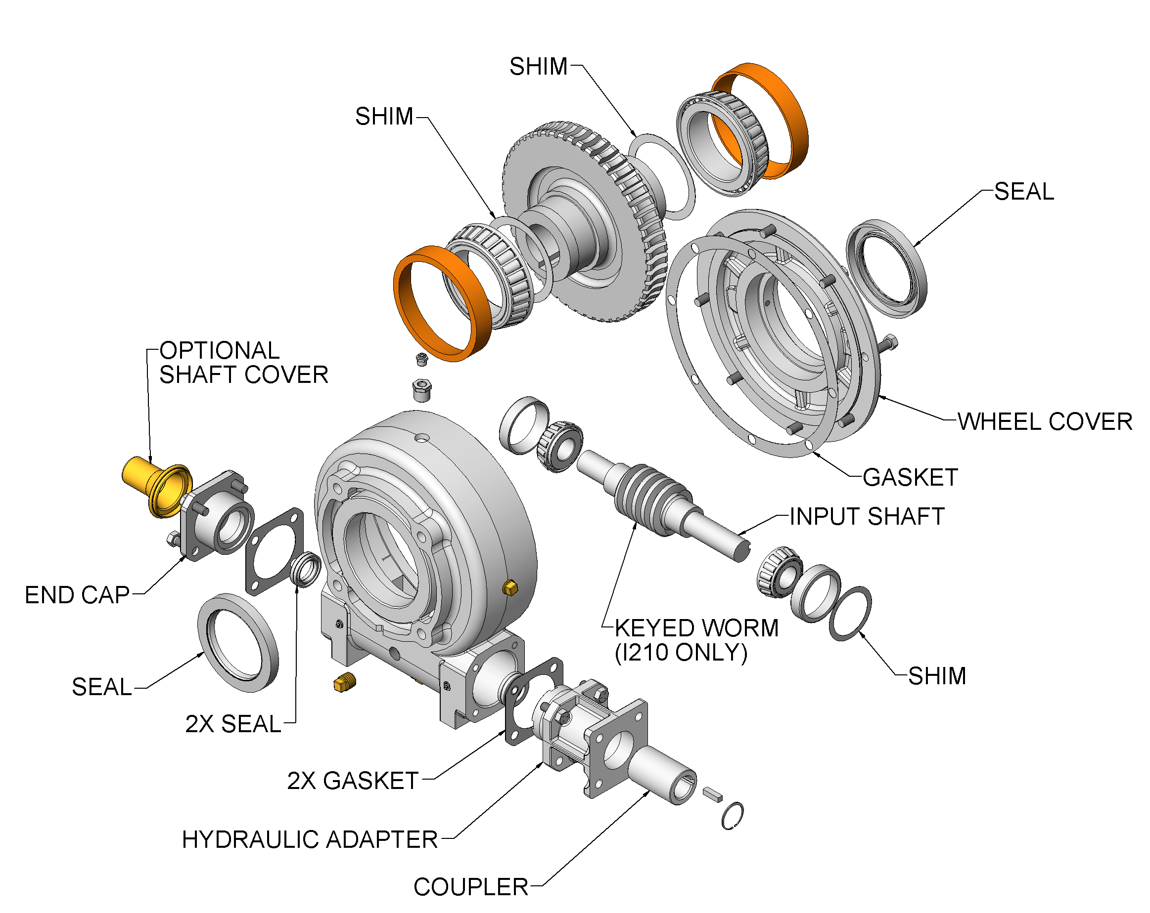

GENERIC WORM GEAR DRIVE ILLUSTRATION

HOLLOW BORE UNIT

SUPERIOR GEARBOX COMPANY
PO Box 645, Stockton, Missouri, 65785 1-800-346-5745
417-276-5191 FAX 417-276-3492 superiorgearbox.com

I210/I260/I280 WORM GEAR DRIVES

SERVICE MANUAL

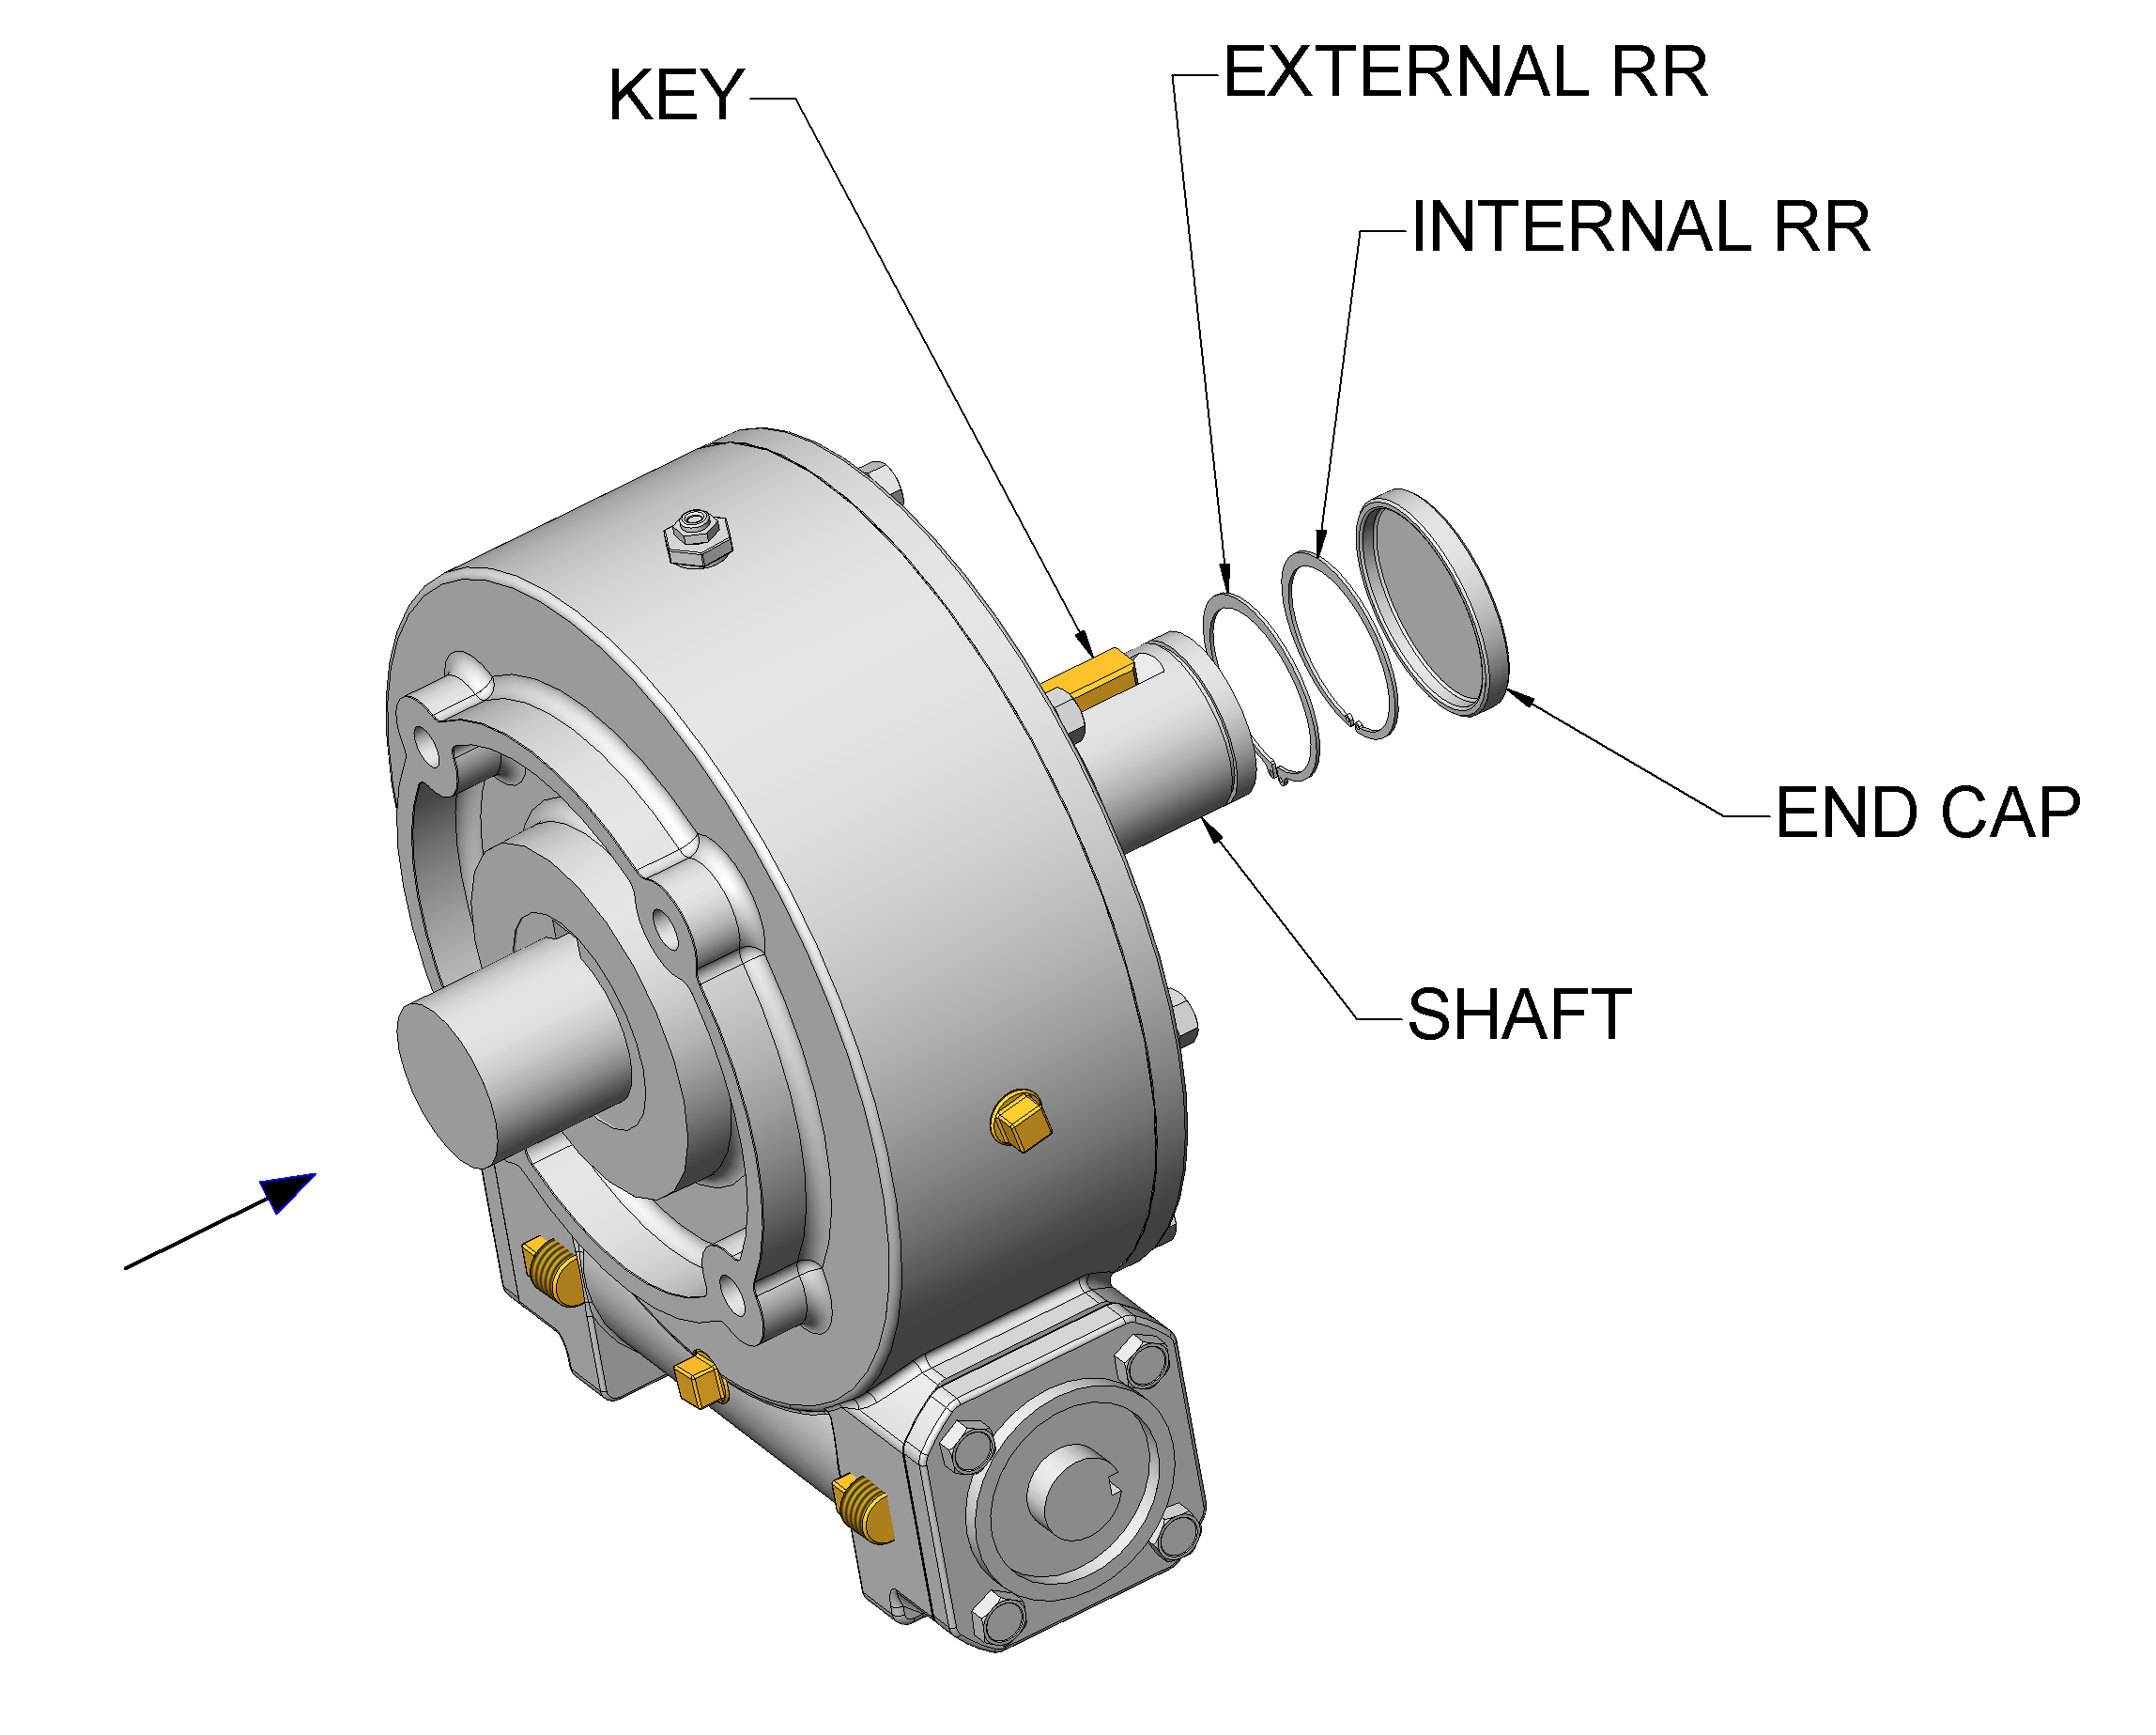

INSTALLATION OF OUTPUT SHAFT INTO HOLLOW BORE WORM DRIVE

1. PUSH SHAFT (IN DIRECTION OF ARROW) UNTIL IT PROTRUDES FROM FROM FAR SIDE
2. INSTALL KEY INTO SHAFT
3. INSTALL EXTERNAL RETAINING RING INTO GROOVE ON END OF SHAFT
4. PULL SHAFT BACK THRU HOLLOW BORE UNTIL RETAINING RING SEATS AGAINST
INTERNAL SHOULDER
5. INSTALL INTERNAL RETAINING RING INTO GROOVE OF HOLLOW BORE. THIS WILL TRAP
THE SHAFT RETAINING RING BETWEEN THE HOLLOW BORE SHOULDER AND THE
INTERNAL RETAINING RING
- PRESS THE END CAP INTO THE WORM DRIVE COVER

SUPERIOR GEARBOX COMPANY
PO Box 645, Stockton, Missouri, 65785 1-800-346-5745
417-276-5191 FAX 417-276-3492 superiorgearbox.com
SUPERIOR GEARBOX COMPANY
PO Box 645, Stockton, Missouri, 65785 1-800-346-5745
417-276-5191 FAX 417-276-3492 superiorgearbox.com

I210/I260/I280 WORM GEAR DRIVES

SERVICE MANUAL

TROUBLESHOOTING

SYMPTOM PROBABLE CAUSE REMEDY

Breather leaking Incorrect oil level Check oil level RPM too high Reduce RPM
Unit running hot Provide additional cooling

Unit running hot Incorrect oil level Check oil level
Inadequate air flow Provide additional cooling
Excessive RPM or load Change to synthetic oil
Contaminated oil Replace oil
Failing bearings Replace bearings

Unusual noise Gear mesh changed Inspect driveline
Excessive external load Inspect belt tension
Failing bearings or gears Replace bearings or gears

Oil leaking Failing seals Replace seals
Mating surfaces Rebuild gear drive

Vibration Loose mounting bolts Inspect / tighten
Loose couplers, pulleys Inspect / tighten
Failing bearings or gears Replace bearings or gears
Driveline misalignment Correct misalignment

SUPERIOR GEARBOX COMPANY
PO Box 645, Stockton, Missouri, 65785 1-800-346-5745
417-276-5191 FAX 417-276-3492 superiorgearbox.com

